Thank you for your referral to the HENRY programme

Eligible groups
- Families with children 0-7yrs, who live in Croydon (or registered with a Croydon GP)
AND
- Families with children whose weight is above the 91st weight centile OR
- Families from areas with higher rates of obesity at reception and year 6 (see map in Appendix A) OR
- Ethnic groups with higher rates of obesity - Black African or Black Caribbean (see graph in Appendix B) OR
- Other high-risk groups e.g. children with a physical or learning disability OR
- Families whom the evidence base suggests would benefit from additional healthy behaviours support
Parent/s or carer/s details
First name/s
Surname/s
Address and postcode
Email
Preferred contact telephone number
First language | Choose an item.
Interpreter required including sign language? | Yes/No
Youngest child’s details (0-7yrs)
First name
Surname
Date of birth

Reason for referral (Tick all that are relevant)
Please tick: |  | Child’s weight over the 91st centile. Please provide centile, or height and weight if available
 |  | Child’s weight is increasing over time but not yet over the 91st centile.
 |  | Parental overweight or obesity or overweight or obesity in older siblings (only if in eligible area/group)
 |  | From at risk ethnic groups* (see Appendix B) | Black African
 |  |  | Black Caribbean
 |  | Child with LTC, SEND or physical disabilities
 |  | Family have requested support for parenting, food, activity, diet (only if in eligible area/group)
 |  | Managing food behaviours at meal times (only if in eligible area/group)
 |  | Support with cooking on a budget (only if in eligible area/group)
By checking this box, you are confirming that the client is aware of and agrees with this referral and understands that their information is being shared with HENRY for the purpose of processing the referral.
If the client requires more information regarding our privacy policy, please direct them to our website https://www.henry.org.uk/privacypolicy
Please tick box to show that you have understood.◽
Referrer’s details
Name
Role

Please send this form to croydon@henry.org.uk, via secure platform or password protected email.

The parent will be contacted within 3 working days.

Information for practitioners:
- HENRY is a national children's charity that focuses on supporting families to lead healthier lives.
- We are an evidence based service that encompasses a whole host of different topics relating to healthy family lifestyle and getting children off to the best start - including.. healthy eating, family activity, emotional and mental health, parental confidence and parenting skills, oral health and much more.
- The HENRY approach works by supporting families in a “partnership” approach, whereby we:
  - …start where families are
  - …help families identify what is going well
  - …build parental confidence
  - …support families to make small, manageable steps toward their preferred future
- HENRY has been commissioned by Croydon Council as the provider for the Early Years Healthy Behaviours service (Tier 1 and Tier 2) until 2026.
- Tier 1 relates to workforce training for local practitioners
  - Practitioners who work directly with families with children 0-7yrs are eligible.
  - We are targeting practitioners that work with “high-risk” parents
  - If you are interested in joining an upcoming training, email croydon@henry.org.uk

Tier 2 relates to direct delivery of group programmes for families
- HENRY programmes run over 8 consecutive weeks, covering a variety of topics.
- We deliver programmes face-to-face in local community venues, as well as having an option to join online.
- Families receive a toolkit full of resources.
- Programmes begin January 2023.
- Please signpost families to our website www.henry.org.uk / our Facebook www.facebook.com/HENRYinCroydon / to contact us directly on 0208 156 6400 for more details

Thank you for your support.

Appendix A: Rates of obesity across Croydon
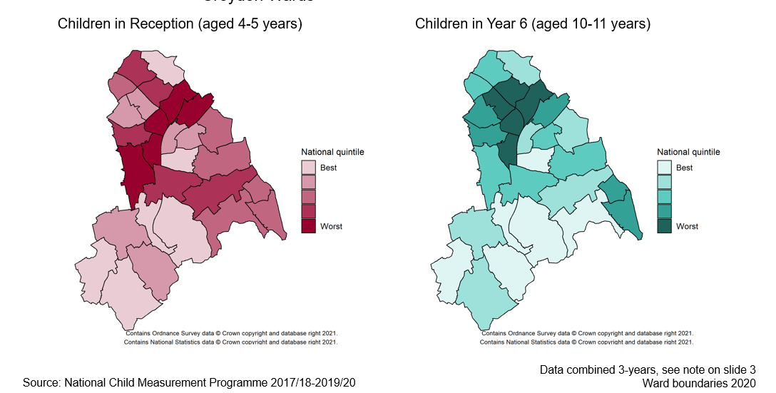

Appendix B: Rates of obesity by broad ethnic grouping
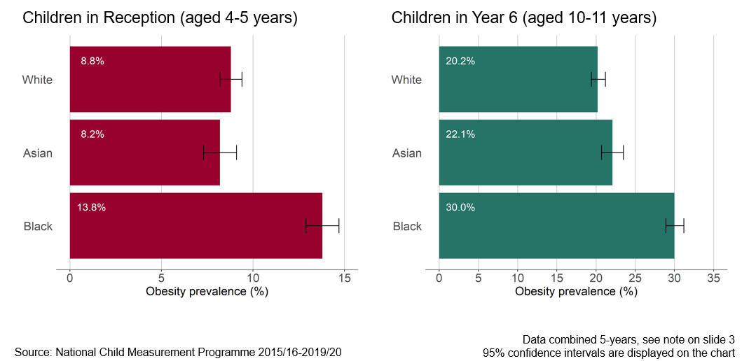

Privacy Policy (Services for parents & carers)
HENRY is a charity which supports families to give their babies and children the best possible start in life. This means supporting the whole family to make positive lifestyle changes, creating healthier and happier home environments, and building healthier communities.
We collect personal information from you to support the services and trainings we provide. For example, we might need information from you to give you a place on a HENRY programme, to complete a sale in our shop, or to provide information you’ve asked for. This page will let you know how we use and protect your personal information.
We respect your privacy and we promise to keep the data you share with us safe. We aim to be clear about the data we collect and not to use it in ways you would not reasonably expect. If you have any questions, please email us at data-support@henry.org.uk. Our postal address is 6 Elm Place, Old Witney Road, Oxfordshire, OX29 4BD and our contact number is 01865 302973.
Below we have answered a range of questions that will help you better understand what personal information we collect, how we use it and how we keep it safe.
HENRY is registered under the Data Protection Act 2018 as a Data Controller with the Information Controller's Office (ICO) under number Z2779782. HENRY is a registered charity and company under guarantee in England and Wales under numbers 1132581 and 6952404.
What is personal data?
Your personal data is any information that can be linked to you by an ‘identifier’ such as your name, your email address or your bank details. Some personal data is more sensitive than others, but HENRY takes seriously its responsibility to protect any data you share with us.
What you share with us will vary depending on your relationship to HENRY and how you interact with our services. We explore this in more detail in the section ‘How do we use your personal data?’ below.
We can only collect personal data from you if we have a lawful basis for doing so. A lawful basis might be your consent, a legal obligation, or a legitimate interest (such as providing a service you have requested). We discuss this further in the next section.
On what grounds does HENRY make use of personal data?
HENRY is careful to be sure we have a sound lawful basis for making use of your personal data. In most cases we will ask for your consent to do so, in others we may use legitimate interests as the lawful basis to process your data.
Your data should not be used in ways you would not reasonably expect and should have as small an impact on your privacy as possible.
Importantly, you have the right to object to how we process your data. For more information, see the section ‘Your Rights’.
How do we keep your data safe?
HENRY is committed to protecting the personal information you entrust to us. We ensure this in three ways:
Security and privacy. We take care to ensure your personal information is processed securely. We have security measures in place to protect and limit access to our offices, servers and remote storage facilities. We anonymise your personal information at the earliest opportunity to protect your privacy.
Reasonable retention. We only keep your personal information for as long as reasonably necessary to achieve the purpose it was needed for. When your personal information is no longer needed, we make sure to anonymise or securely destroy it.
Responsible sharing. We only share your personal information with trusted organisations (see the section below for more information on who they might be). Where we share your personal information, or where a third party data processor handles your information for us, we ensure agreements are in place to safeguard your privacy.
Who do we share your personal data with?
HENRY puts strict limits on how your data is shared and will do our best to tell you in advance when your data will be shared. Below is a rundown of the organisations we may share data with.
We will not rent or sell your personal information to other organisations for use by them in any way.
With our local partners
We may share your personal data with our local partners if this is necessary to deliver a HENRY service to you. Normally we will only share information which is needed to deliver the service you’re interested in. For example, if you contact us about joining a HENRY parent programme, we will share the personal information your local service provider needs to tell you about programmes in your area. This might include your name, contact details, and relevant information about you and your family.
Our local partner may be your council, a local trust or charity, or a similar organisation. You can contact us to find out more about HENRY’s local partners in your area. A list of partners can be found here.
In some cases (such as HENRY's community projects), we collect personal information on behalf of the local authority, who control how that data is processed, used and shared. We will do our best to inform you in advance when we are processing your personal information on behalf of someone else.
With our academic partners
HENRY shares anonymous data from our parent programmes and practitioner training courses with academic partners for research purposes. This research helps us to improve HENRY services, understand how they affect different people and prove that they work. When we say that data is ‘anonymous’, we mean that all identifiers have been removed or replaced with a pseudonym, so that this information cannot be linked back to you. The kind of anonymous data we share includes things like participants’ sex, ethnic background and postcode, how often they eat fruit and vegetables and how often they attended HENRY programmes.
Below is a list of HENRY’s current academic partners. For more information about what we share, see the section ‘How does HENRY use your personal data?’. Our current academic partners are listed below:
The University of Hertfordshire
The University of Leeds
Oxford Brookes University
University of Swansea
University of Roehampton
With third party providers of online tools
HENRY currently uses third party online tools to carry out some processes, such as large mailings, surveys and processing payments. We share only the personal information necessary to deliver the service we need and take care to be sure that third party providers respect your privacy and protect your data.
Google Analytics
We use Google Analytics on our website to collect standard internet log information and details of visitor behaviour patterns, which you use to understand how people use our website and to improve their experience. We do not allow Google Analytics to collect any identifiers, such as IP address, so this information is anonymous. Read more here.
Google Forms
We sometimes use Google Forms to collect information from you if you want to access some of our services, including personal data and special category data. You will see privacy notices on our Google Forms and where appropriate we ask you to consent to sharing your information with us. You can find Google's privacy information here.
Google Drive
We use Google Drive to store all our data. This has been specifically chosen as we can store all information within the EEA. Data is secured both when being transferred and stored. Please see Google Drive's privacy policy for more information.
Google Calendar
We use Google Calendar to host our event information. When invited to an event, participants will not be able to view details of anyone else on programmes or training, except for the organiser. Please see Google Calendar's privacy policy for more information.
Backupify
We use Backupify to back up all data from Google Workspace (Drive, Calendar and Contacts). This is hosted within the EEA. Please see Backupify's privacy policy for more information.
PayPal
We use PayPal to process payments for purchases made in our online shop. If you buy something from our website, PayPal will process this transaction and receive the relevant information you choose to share, e.g. name, email address, billing address, bank details. Read PayPal's privacy policy.
Charities Aid Foundation (CAF) and Just Giving
We use these providers to process some donations.
If you make a donation via our website, this will be processed by CAF and they will receive the relevant information you choose to share with them. Read CAF's privacy policy.
If you make a donation via text, this will be processed by Just Giving and they will receive the relevant information you choose to share with them. Read Just Giving's privacy policy.
HubSpot
We use HubSpot to maintain mailing lists, other contact details and to email large groups of recipients, so we may share your name and email address with HubSpot. We will not use mailing lists to contact you for the purpose of direct marketing unless you have consented for us to do so, and you can withdraw your consent at any time by clicking the ‘unsubscribe’ button in an email or by emailing it-support@henry.org.uk or your local HENRY service. Please see HubSpot’s privacy policy for more information.
ClickSend
We use ClickSend to maintain telephone lists and to text large groups of recipients, so we may share your name and telephone number with ClickSend. We will not use your telephone number to contact you for the purposes of direct marketing unless you have consented for us to do so. You can unsubscribe by emailing it-support@henry.org.uk or your local HENRY service. Please see ClickSend’s privacy policy for more information.
Google Meet/Zoom/Microsoft Teams
We use Google Meet, Zoom and Microsoft Teams for video communication. When inviting you to an event we use your email address, so we may share this with the relevant provider. Please see Google Meet’s, Zoom’s or Microsoft Team’s privacy policy for more information.
Legal obligations and special circumstances
We may share your personal information with third parties if we are legally obliged to; or in order to enforce or apply the terms of an agreement; or to protect the rights, property or safety of HENRY, our donors or others. This includes exchanging information with other companies and organisations for the purposes of fraud detection and protection, or with local authorities or social services for the purposes of the provision of health, legal or social care or treatment
Where is your data stored?
HENRY’s offices and servers are based in the UK. HENRY also uses Google Workspace to host data in the cloud, where your personal information may be stored on servers in the UK or inside the EEA (European Economic Area). In both cases we have taken all steps reasonably necessary to make sure that your data is treated securely and in accordance with this privacy policy. We have done our best to protect your personal data, and ensured that it will be held in compliance with European data protection regulations.
For more information on our third party providers of online tools, see the section ‘Who do we share your personal data with?’ above.
In cases when we use external websites provided by other organisations such as Twitter, YouTube or Facebook, we ask that you consult their respective privacy policies.
Unfortunately, the transmission of information via the Internet is never 100% secure and we cannot guarantee the security of your data transmitted to our website. This means any such transmission is at your own risk.
How will we contact you?
If you share your contact details with us, we will use these to get in touch in a couple of circumstances, which we talk more about below. We promise not to bury you in emails!
To provide a service you have requested. If you make an enquiry to HENRY by phone or email, we will use your contact details and any other personal information you share to answer your enquiry. If you wish to access a HENRY service, we will ask you for the personal information we need to provide access to that service and use it for that purpose.
For research purposes. If you attend a HENRY programme for parents or carers, or HENRY training for practitioners, we may contact you about 6 months after you attend with a short e-survey. This helps us to investigate the long term impact of our services. In rare cases, we may contact you again up to 5 years later to ask if you would be willing to help with further long term research.
With your consent. If you provide us with your consent to do so, we will add you to our mailing list. We will email you now and again with HENRY info updates, surveys and fundraising appeals. You can withdraw your consent at any time – either by using the Unsubscribe option when we contact you, or by emailing info@henry.org.uk.
How does HENRY use your personal data?
In this section, we look in more detail at the personal information we collect from you: what we collect, how and why we use it, and how long we keep it.
Services for parents & carers
When you attend one of HENRY’s programmes or workshops for parents & carers, or contact us about any of our services, we ask you to share the information we need to provide this service to you and to evaluate its impact on families. We do not share this information except as described in the section above, 'Who do we share your personal data with?' None of this information is used to make decisions about you or your family.
We would use the name and contact details you provide to provide you with access to our services. Below you can find more detail on how we use your personal information after you finish engaging with a HENRY service.
We collect the personal information we need from you to give you access to our services. We may also record your attendance at programmes and workshops. We may collect information about you or your family via feedback questionnaires: sometimes one before accessing a service, one towards the end and sometimes one more about 6 months after you finish.
We store attendance and questionnaire data with your name for up to 7 years. After 7 years, this information is pseudonymised, so that no one can be identified, and stored indefinitely for statistical and research purposes. We may share this data anonymously with our research partners.
Name. We may use your name to match your feedback responses, so that we can understand how families’ lifestyles change over the course of accessing HENRY services. We keep your name for up to 7 years after you attend. After 7 years, we delete your name and pseudonymised all the personal information we hold on you.
Contact details. We may use your contact details to deliver a follow-up e-survey about 6 months after engaging with a HENRY service. In rare cases, we may contact you again up to 5 years later to ask if you would be willing to help with further long term research.
With your consent, we also add your email address to our mailing list. We use this to send occasional emails such as HENRY info updates, surveys and fundraising appeals. You can withdraw your consent at any time – either by using the unsubscribe option when we contact you, or by emailing info@henry.org.uk.
If you consent to be added to our mailing list, we will keep your email address until such time as you unsubscribe. If you do not consent, we will make no further use of your email address or other contact details.
Attendance information. We may record which sessions of a programme or workshop you attend, including reasons for non-attendance and referral information. We use this information to evaluate the support facilitators provide to participants and to evidence and improve the attendance rate of HENRY's programmes.
Lifestyle information and feedback. We may use the information you provide in the feedback questionnaires to evaluate the impact of the programme on families who take part and to provide evidence of its effectiveness. We may use your comments anonymously as part of our promotional materials and bids to commissioners.
Demographic information. Sometimes we ask you to tell us your: age; postcode; gender; ethnic background; disability status; number and ages of your children. This information helps us to understand who attends the programme and how it affects different groups of people. We use this information to improve the programme, make it more accessible, and to help make the case for funding. For example, we might look at the ethnicity of participants on the programme when deciding on what languages we should translate the programme into to make it more accessible.
Please note, our lawful basis for processing this special category information is explicit consent (Article 9(2)(a) GDPR).
If you take part in an online programme or workshop we may record this. We use these recordings internally for our own training and quality assurance purposes and retain them for 6 months. Our lawful basis for doing this is legitimate interests (Article 6(1)(f) GDPR).
Your rights
As an individual whose personal data is processed by HENRY, you have the following rights:
The right to be informed – which is the purpose of this privacy notice
The right to access – to see what data we hold on you
The right to rectification – for corrections to be made if data on you we hold is inaccurate
The right to erasure – in some circumstances, of data we hold on you
The right to restrict processing of information we hold on you
The right to data portability, if applicable
The right to object:
to direct marketing – by clicking the Unsubscribe option or by contacting us directly
to processing of your data on the basis of our legitimate interests
to processing of your data on the basis of your consent
To exercise your data rights, please contact us by emailing data-support@henry.org.uk or calling 01865 302 973.
Updates or changes to this Privacy Policy
This Privacy Policy was last updated in October 2022
We reserve the right to make changes to this Privacy Policy. You should check this Privacy Policy at https://www.henry.org.uk/privacypolicy to check that no changes have been made to any sections that are important to you. Where appropriate, we will let you know about any changes by email, via our newsletter.
Complaints
If you have any questions or concerns about this privacy policy and our privacy practices or if you wish to file a complaint, please contact us by emailing info@henry.org.uk or calling 01865 302 973.
You have the right to lodge a complaint with the Information Commissioners Office (ICO) if you believe your data has been processed in a way that does not comply with the relevant data regulations. You can do so by calling the ICO helpline on 0303 123 1113 or via their website.

