Car Park

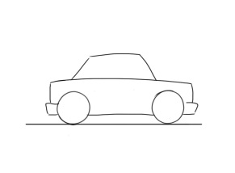

Parent of a healthy family

HEALTHY FAMILY
DAILY ROUTINES

BOOSTING

OUR

BATTERIES

Connect | Be active | Take notice | Keep learning | Give

