**Car Park**

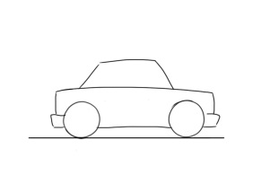

|  |  |
| --- | --- |
| **Typical family meals** | **Typical family snacks** |
|  |  |

|  |  |  |
| --- | --- | --- |
| **Love** | **Time and attention** | **Praise and encouragement** |
|  |  |  |